 |  | ANNEXURE –C
DAV PUBLIC SCHOOLS, ODISHA ZONE
HALF YEARLY EXAM (2023-24) CLASS : III SUBJECT : SOCIAL SCIENCE
MARKING SCHEME
QN NO. | Value Points |  | Marks Allotted | PAGE NO. OF NCERT /TEXT BOOK
1a | Sharma |  | 1 | 2
b | 195 |  | 1 | 12
c | Himachal Pradesh |  | 1 | 27
d | Rivers |  | 1 | 34
e | Farming |  | 1 | 42
2 | 1-d,2-e,3-a,4-c |  | 4 | 17,25,26
3a | Soldier |  | 1 | 2
b | Badminton |  | 1 | 12
c | Kerala |  | 1 | 39
d | Child |  | 1 | 42
4a | Nuclear family |  | 1 | 4
b | Spear |  | 1 | 33
c | Panjiri |  | 1 | 17
d | Phiran |  | 1 | 26
5a | Colours, Flowers |  | 1 | 3
b | Nylon, Polyester |  | 1 | 25
c | Colour of the skin,shape of the nose |  | 1 | 10
d | Dhabas, carpet weaving factory |  | 1 | 45
6a | If the twins are identical it is difficult to tell who is who! |  | 1 | 11
b | Silk comes from silkworms. |  | 1 | 26
c | From other countries people come to India for medical treatment which is known as Medical Tourism. |  | 1 | 41
d | Sivakasi in Tamil Nadu is famous for its matchbox and firecracker factories. |  | 1 | 46
7a | i.Vishu’s grandmother runs a training centre to teach embroidery to women from a nearby slum.  ii.She sells their goods to a handicraft centre which helps them to earn money. |  | 2 | 2
b. | i. Buy only what you need.  ii. Cook it with love. |  | 2 | 20
c. | i. Climate  ii. Culture and tradition of the people. |  | 2 | 25
d. | i. The fire gave him warmth in cold, saved him from wild animals.  ii. Fire helped him to cook raw food to make it soft and tasty. |  | 2 | 33
e | i.All types of work are necessary in a society.  ii.No work is superior or inferior. |  | 2 | Own Answer
f | i.Every child has a right to free and compulsory education up to 14 years of age.  ii.Children will be motivated and get a chance to go to school to read and write which will help them for a better future. |  | 2 | 47
8a) | i. He stopped wandering from place to place.  ii. He started leading a settled life close to the land where he grew grains.  iii. His shelter changed from caves and trees to thatched huts.  OR  i.He sowed seeds, watered the plants and waited for the grains to ripe.  ii.He cut the crops and stored the grains.  iii. He made better tools , baskets of reeds and clay pots for storing and cooking the grains. |  | 3 | 33,34
b) | i.Dr. APJ Abdul Kalam was born on 15th October 1931 in a small village Rameshwaram in Tamil Nadu.  ii.As a school student, Dr. Kalam sold newspapers to continue his education.  iii. He became a great scientist and won many awards like Padma Bhusan, Padma Vibhushan, Bharat Ratna and many others.  iv.He was the eleventh President of India.(Any three)  OR  i.Parents will unable to provide food and clothes to children.  ii.Children will not get proper education.  iii.Children will be forced to work or beg to fulfil the needs of their families. |  | 3 | 45  46 & own answer
c) | i. Komal wasted food.  ii. I will tell him/her not to waste food because nature gives us food to eat, not to waste.  iii. Concern for others, caring |  | 3 | own answer
9 | Map attached. |  | 4

9 | 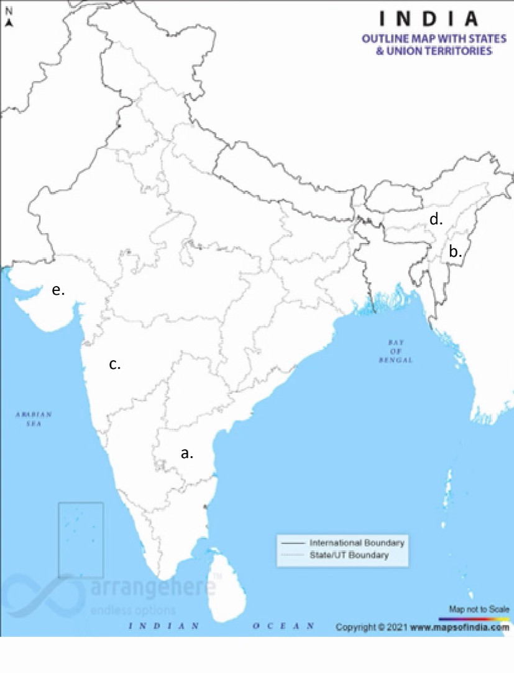 | 4(Any four)

