**DAV PUBLIC SCHOOLS, ODISHA ZONE B & C**

**QUESTION BANK**

**SUB: MATHEMATICS, CLASS -IX**

**(2023-24)**

**TEXT BOOKS: NCERT MATHEMATICS STD -IX**

**EXEMPLAR PROBLEMS OF MATHEMATICS STD-IX**

**EXAM SCHEDULE 2023-24**

|  |  |  |
| --- | --- | --- |
| **NAME OF THE EXAM** | **DATE** | **FULL MARKS** |
| **PRIODIC ASSESSMENT-1** | **24-JULY 2023 TO 31 JULY 2023** | **40** |

**SYLLABUS**

|  |  |  |
| --- | --- | --- |
| CHAPTER | Periodic Assessment-I | Marks(40 Marks) |
| Chapter-1 | Number System | 10 |
| Chapter-2 | Polynomials | 10 |
| Chapter-3 | Co-ordinate Geometry | 8 |
| Chapter-5 | Introduction to Euclid’s Geometry | 2 |
| Chapter-6 | Lines and Angles | 10 |

**TYPOLOGY OF QUESTIONS**

|  |  |  |
| --- | --- | --- |
| 1 | MCQ | 1 MARK |
| 2 | ASSERTION AND REASON BASED QUESTIONS | 1 MARK |
| 3 | SHORT ANSWER TYPE QUESTION-I | 2 MARKS |
| 4 | SHORT ANSWER TYPE QUESTION-II | 3 MARKS |
| 5 | LONG ANSWER TYPE QUESTION | 5 MARKS |
| 6 | CASE BASED QUESTIONS | 4 MARKS |

**QUESTION BANK**

**CHAPTER: NUMBER SYSTEM**

**MULTIPLE CHOICE QUESTIONS (1 MARKS)**

1. The value of ${27}^{\frac{-2}{3}}$ is

$a. \frac{2}{9}$ b. $\frac{1}{9}$ c. 9 d. $\frac{5}{9}$

1. If = 1-2x then the value of x is

$a. \frac{7}{5}$ b. $\frac{5}{26}$ c. $\frac{3}{2}$ d. $\frac{3}{4}$

1. If a = bx, b = cy, c = az, then xyz is

a. -1 b. 0 c. 1 d. abc

4. when rationalized becomes 3 - $\sqrt{n}$,what is the value of n?

a.1 b. 2 c. 3 d. 7

5. If 3x = 4y = 12z, then the value of z is

a. xy b. x + y c. d. 4x + 3y

6. The value of 1. $\overline{79}$ in $\frac{P}{q}$ form, where p and q are integers is:

a. b. c. d.

7. The value of x-y in a challenge problem x-y $\sqrt{6}$ = $\frac{5-2\sqrt{6}}{5+2\sqrt{6}}$ given by Priya to her friend Riya is:

a. 24 b. 12 c. 30 d. 29

8. A girl saw an expression (49)0.16 x (49)0.09and was curious to solve it . The value obtained from the expression is

a. 49.25 b. c. 7 d. 49

9. During the maths class, the teacher instructed Riya to insert a rational and an irrational number between 5 and 7. Which of the following cannot be an answer?

a. 6 b. c. d. 7.5

10. Some of the rational numbers between 7 and 11can be expressed in the form m/6, where m belongs to a set of natural numbers. Which of the following statement is true?

a. All possible values of m lie between 42 and 66.

b. All possible values of m lie between 42 and 77

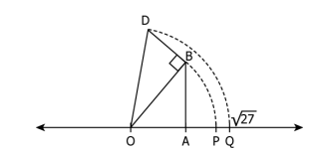 c. All possible values of m lie between 48 and 60.

d. All possible values of m lie between 66 and 77

11.Kevin’s work to represent 27 on a number line is shown.

In the number line, arc DQ is drawn using OD as the radius.

Looking at Kevin’s work, Tina and Ajay made following

statements. Tina: OA = 5 units, AB = BD = 1 unit

Ajay: OB = 26 units and AB = 1 unit Who is correct?

a. Only Tina b. Only Ajay c. Both of them d. Neither of them

12. An expression is given: 2($\sqrt{k}$-1) + $\sqrt{8 . }$ If on adding -8 $\sqrt{2}$ to the expression results in a rational number, the value of k is?

a. 6 b. 12 c. 18 d. 36

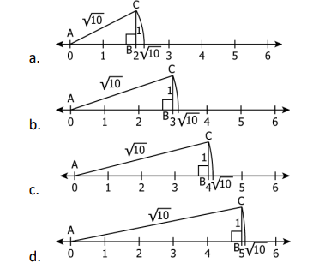 13. Identify from the following that

represents $\sqrt{10}$ on a number line

14. Shruti has one rational number x and Dhruti has an irrational number y and now they want to multiply them. The product so, obtained will be?

1. An irrational number b. A rational number

c. none of them d. cannot be determined

15. On adding https://www.careerlauncher.com/cbse-ncert/class-9/9-math-num-3-UntitOE16.JPG we get

      a.https://www.careerlauncher.com/cbse-ncert/class-9/9-math-num-3-UntitOE17.JPG b.https://www.careerlauncher.com/cbse-ncert/class-9/9-math-num-3-UntitOE18.JPG c.https://www.careerlauncher.com/cbse-ncert/class-9/9-math-num-3-UntitOE19.JPGd.none of these

16.  On dividing https://www.careerlauncher.com/cbse-ncert/class-9/9-math-num-3-UntitOE20.JPG we get

     a.https://www.careerlauncher.com/cbse-ncert/class-9/9-math-num-3-UntitOE21.JPG b.6 c.9 d.none of these

17. https://www.careerlauncher.com/cbse-ncert/class-9/9-math-num-3-UntitOE22.JPG is

     a.an irrational number b. a positive rational number

       c. a negative rational number d. an integer

18. For rationalising the denominator of the expression https://www.careerlauncher.com/cbse-ncert/class-9/9-math-num-3-UntitOE30.JPG we multiply and divide by

      a. https://www.careerlauncher.com/cbse-ncert/class-9/9-math-num-3-UntitOE31.JPG b.12 c.   https://www.careerlauncher.com/cbse-ncert/class-9/9-math-num-3-UntitOE32.JPG d.   https://www.careerlauncher.com/cbse-ncert/class-9/9-math-num-3-UntitOE33.JPG

19. is equal to

a. 9√10 b. √5+√2 c. √7 - √2 d. 8√10

20.Find which variables represent rational

a.x²=5 b. $x²=\frac{17}{4}$ c. v²=3 d. y²=9

**ASSERTION AND REASON BASED QUESTIONS( MCQ)**

(a)Both A and R are true and R is the correct explanation of A.

(b)Both A and R are true and R is not the correct explanation of A.

(c)A is true but R is false.

(d)A is false but R is true.

CHOOSE ONE CORRECT OPTION FOR EACH OF THESE QUESTION.

21. A: 2 is a rational number

R: The square roots of all positive integers are rational.

22. A: Sum of two irrational numbers $5+\sqrt{3}$ and $4+\sqrt{3}$ is rational number.

R: Sum of two irrational numbers can be rational/an irrational number.

23. A: = a +b then a x b = 36

R: The value of a and b are 18 and 2 respectively.

24. A: The x = is an irrational number.

R: The product of two irrational numbers is an irrational number.

25. A: If x=1+ + and y= 1 + - then xy =6 + 2

R: (a+b)(a-b)=a2- b2

26. A: 34.12345 is a terminating decimal.

R: Denominator of 34.12345 when expressed in the form p/q,q $≠$ 0,is of the form 2m x 5n,where ma and n are non-negative integers.

27. A: One rational number lying between 4 and 5 is 4.5

R: Rational number lying between two rational numbers x and y is ½ (x+y)

28. A**:** If  = 1.414,  = 1.732, then  =  +  .

R **:** Square root of a positive real number always exists.

29. A**:** 172 175 = 173

R**:** If *a* > 0 be a real number and *p* and *q* be rational numbers. Then *ap**aq*= *ap*+*q*.

30. A: 0.271 is a terminating decimal and we can express this number as 271/1000

which is of the form *p*/*q* , where *p* and *q* are integers and *q*0.

R **:** A terminating or non-terminating decimal expansion can be expressed as rational number.

**SA-I TYPE QUESTIONS (2 MARKS)**

31. Find the value of .

32. If ax = bc, by = ca, cz = ab, show that xyz = x + y + z + 2.

33. If x , find the value of x.

34. Insert two rational and two irrational numbers between 0.2 and 0.25.

35. If (7 + )2 + (7 - )2 a rational number ? Justify.

36. Solve the expression and obtain a whole number

4 – 2 + 9 - 45

37. Evaluate

38. Rimmy was given an expression $\frac{[{\left(81\right)}^{3.6} x ({9)}^{2.7}]^{2}}{{(81)}^{8.4} x 27}$ and he was asked to find the

First multiple of the answer obtained.Find the first multiple ?

39. An expression is given 2( $\sqrt{k}$– 1)+ $\sqrt{8}$.If we add -8 $\sqrt{2}$ to the expression, the result

obtained is a rational number,find the value of k.

40. x= – 1, then find the value of (x - )5.

**SA –IITYPE QUESTIONS ( 3 MARKS)**

41. If x = , show that x2( x – 10 )2 = 1.

42. Pinku has $\sqrt{2 }$ = 1. 414 & Minku has $\sqrt{3 }$ = 1. 732 (approx.), together they form the expression $\frac{4}{3\sqrt{3}- 2\sqrt{2}}$ + $\frac{3}{3\sqrt{3} + 2\sqrt{2}}$ find the value of the expression up to three decimal places.

43. Find the value of - 3(5)0 - .

44. Express 3.41 $\overline{21}$ in the form of $\frac{p}{q}$ where p and q are integers and q0.

45. For = a + ,then find the values of a and b.

46. If a= and b= find the value of a2+b2-ab?

47. Represent on the Number line.

48. If x,y,z are real nos. show that 

49. If x= 7+, find .

50. Simplify: ${64}^{-\frac{1}{3}}({64}^{\frac{1}{3}}-{64}^{\frac{2}{3}})$

**LONG ANSWER TYPE QUESTIONS:(5 MARKS)**

51. If x= , show that 3ax2 – 2bx + 3a = 0

52. If , find the value of – 7 + .

53. Find the value of - + .

54. Evaluate 

55. If A=0.3636….. and B= 0.6363…… then find + .

56. Find the value of .

57. If =343, then find the value of (n+1)2 – (n-1)2.

58. Find 8 rational numbers between $\frac{7}{13}$ and $\frac{8}{13}$ and also find x+1, if x is 4th rational number from the left.

59. If a and b are rational numbers and (a-3) $\sqrt{6}$ + 7= b $\sqrt{6}$ + a, find a2+b2 also find the value of x if a2+b2 when divided by 13 gives quotient x.

60. Find the value of $\frac{4}{{(216)}^{-\frac{2}{3}}}+\frac{1}{{(256)}^{-\frac{3}{4}}}-\frac{2}{{(243)}^{-\frac{1}{5}}}$

**CASE BASED QUESTIONS**

**VACCINATION DRIVE:**

1. In January 2021, the vaccination drive for COVID- 19 started in 7 states of a country. More than 60% of the people were vaccinated in 4 states out of 7 states. In one of the state vaccination drive has not been started due to flood although vaccine dose was supplied to that state in advance. In February 2021, 4 more states were included in this drive and 2 states have got remarkable response from the people and more than 80% of the population got vaccinated there. Using this information answer the following questions.
2. In January 2021, more than 60% of people were vaccinated in 4 states out of 7 states. Find the decimal representation of $\frac{4}{7}$.

(b) If the decimal representation of a number is non-terminating

recurring, then mention the type of number.

(c) In 2 states out of 11 states, more than 80% of people participated in

vaccination drive in two months. Then, find decimal form of $\frac{2}{11}$.

**OR**

The fraction for state where vaccination not started in January 2021is $\frac{1}{7}$ and its decimal form is 0. $\overline{142857}$. Then, find the decimal form of $\frac{6}{7}$.

**ROAD TRIP BY AJAY:**

1. Ajay is on a road trip in his car. He starts his trip on a road at a point A and covers a distance of ($x^{3 }$ + $\frac{1}{x^{3}}$) km in the first lap and reachs the destination B. Then he comes back on the same road for a distance of 5( $x^{2 }$ + $\frac{1}{x^{2}}$) km to reach the destination C. Then he again returns back on the same road covering a distance of ($x^{}$ + $\frac{1}{x}$) km to reach his destination D. If the journey in the direction of AB is taken as positive and $x=\frac{(5+ \sqrt{21)}}{2}$ km then answers the following questions based on this information.



(a) Find the distance travel in the third trip i.e ($x^{}$ + $\frac{1}{x}$) km?

(b) Find the distance from A to B

(c) Find the total distance covered by him from point A i.e

($x^{3 }$ + $\frac{1}{x^{3}}$) - 5( $x^{2 }$ + $\frac{1}{x^{2}}$) + ($x^{}$ + $\frac{1}{x}$) km?

**OR**

Find the final position of Ajay

**CHAPTER: POLYNOMIALS**

**MULTIPLE CHOICE QUESTIONS (1 MARKS)**

1. Given a polynomial of degree $n.$ What could be the maximum terms present in the polynomial?
2. n b.n-1 c.n2 d.n+1
3. Which of the following is a linear polynomial whose zero is 5 less than the smallest two digits composite number?
4. $\left(x-10\right)$ b. $\left(x+5\right)$ c. $\left(2x-10\right)$ d. $(2x+10)$
5. The number of terms present in the polynomial $\frac{4x^{2}-4x+1}{x-\frac{1}{2}}$ is
6. 3 b.2 c.1 d.5
7. For what value of $k,$ the following polynomial P(x) will turn to a binomial

P(x) = $-3x^{3}+kx^{2}-1+x^{2}$

1. 0 b.1 c.-1 d.4
2. If $P\left(x\right)=x^{3}-2x^{2}-x+2,$ then the value of $-P\left(1\right)+P\left(-1\right)$
3. 0 b.1 c.-1 d
4. Which of the following statements is incorrect?
5. Every non-zero constant polynomial has no zero
6. Zero polynomial has no zero.
7. Every linear polynomial has exactly one zero.
8. If $(x-a)$ is the zero of P(x), then P(a)=0
9. if $x+a$ is a factor of $x^{n}+a^{n}$, then Which of the following is true?
$n∈N$

10. For any odd positive integer
11. For any even positive integer
12. For any real number.
13. What is the zero of the products of a constant polynomial and a zero polynomial?
14. 0 b.1 c. Any real number d. Not defined
15. The product of $\sqrt{2}\&\sqrt[3]{3}$ is
16. $\sqrt{6}$ b. $\sqrt[3]{6}$ c. $\sqrt[6]{36}$ d. $\sqrt[6]{72}$
17. Factorization of ${\left(-x-y\right)}^{2}$ is
18. $x^{2}+2xy+y^{2}$ b. $x^{2}-2xy+y^{2}$ c. $-\left(x+y\right)\left(x+y\right)$ d. $(x+y)(x+y)$
19. 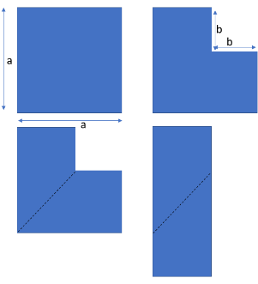The following paper cutting activity shows the proof an algebraic identity. Identify the identity
${\left(a+b\right)}^{2}=a^{2}+2ab+b^{2}$

${\left(a-b\right)}^{2}=a^{2}-2ab+b^{2}$

$\left(x+a\right)\left(x-b\right)=x^{2}+\left(a-b\right)x-ab$

$a^{2}-b^{2}=(a+b)(a-b)$

20. Which of the following will be the factor of $+y+z-2\sqrt{xy}-2\sqrt{yz}+2\sqrt{zx}$?
$\sqrt{x}-\sqrt{y}+\sqrt{z}$

$\sqrt{x}+\sqrt{y}-\sqrt{z}$

$-\sqrt{x}+\sqrt{y}-\sqrt{z}$

21. Both a & c
22. If $a^{3}+b^{3}+c^{3}-3abc=k\left(a+b+c\right)\left[{\left(\frac{a-b}{2}\right)}^{2}+{\left(\frac{b-c}{2}\right)}^{2}+{\left(\frac{c-a}{2}\right)}^{2}\right]$, then $k$ equals to
23. 1 b.2 c.-1 d.4
24. $x^{2}-xy+y^{2}$ is a factor of
$x^{4}+x^{2}y^{2}+y^{4}$

$x^{4}+x^{2}y^{2}-y^{4}$

$x^{4}-x^{2}y^{2}+y^{4}$

$-x^{4}+x^{2}y^{2}+y^{4}$

25. $\sqrt{3}$ is
26. A polynomial of degree ½
27. a linear polynomial
28. a constant polynomial
29. not a polynomial
30. if $2a+2b+2c=0$, then $\frac{a^{3}+b^{3}+c^{3}}{3}=$
31. $\frac{a+b+c}{2}$ b. $\frac{abc}{2}$ c. $3abc$ d. $abc$
32. If p(x)=2x2-3x+5, then the value of $\frac{p(0)+p(1)}{p(-1)}$
33. 1/10 b.4/11 c.9/10 d.4/5
34. If $x+y=-4,$ then the value of $x^{3}+y^{3}+64$ is
35. -64 b.16 c.16xy d.12xy
36. If $2a+b=2 \& 2a-b=1$, then 4 $ab$ equals
37. 1 b.2.5 c.1.5 d.3
38. The value of $\frac{5^{4}+{25}^{3}+{125}^{2}}{51}$ is
39. $5^{1}$ b. $5^{2}$ c. $5^{3}$ d. $5^{4}$

**SHORT ANSWER TYPE QUESTION-I (10 QUESTIONS)**

1. Write two linear polynomials whose zeroes lie between $\sqrt{2}\&\sqrt{3}.$
2. Let $p(x)$& q(x) are the factors of g $\left(x\right).$ Is it necessary that the product of p(x) & q(x) is also a factor of g(x)? Justify by giving suitable example.
3. If the zero of a polynomial P( $x)$ is $m$. How does the zero of the same polynomial change if any non-zero real number is multiplied to the given polynomial? Explain by using suitable example.
4. The zero of $p(x)$ is one more than the zero of $q\left(x\right)=\left(x+2\right).$ Give an example of a linear polynomial $r(x),$ such that the zero of the polynomial is the sum of zeroes of $p(x)$& $q(x)$.
5. P(x) is quadratic polynomial such that p(1)=1, p(2)=2 & p(3)=4, find p(4).
6. Area of a rectangular field is $\left(2x^{3}-11x^{2}-4x+5\right)$ sq. units and side of a square field is $(2x^{2}+4)$ units. Find the difference between their areas
7. Give an example of a pair of linear polynomials whose sum of the zeroes is one of the zeroes of the product of the same polynomials.
8. Factorize: $x^{2}-5x+6$ by using factor theorem.
9. Write in expanded form: ${\left(\frac{1}{x}+y\right)}^{3}+{\left(\frac{2}{x}+2y\right)}^{3}$
10. Using suitable identity, prove that $\frac{({0.52)}^{3}+({0.48)}^{3}}{{(0.52)}^{2}-(0.52×0.48)+{\left(0.48\right)}^{2}}$

**SHORT ANSWER TYPE QUESTION-II (10 QUESTIONS)**

1. If $a^{2}+b^{2}=3ab,$ then find the value of ${\left(\frac{a+b}{a-b}\right)}^{4}$
2. By using suitable identity, find the product of $(2x^{2}-3x+5)×(2x^{2}+3x-5)$ in standard form
3. If $a,b,c$ are non-zero real numbers such that $a^{2}+b^{2}+c^{2}=ab+bc+ca,$ then show that $a^{3}+b^{3}+c^{3}=3abc$
4. If $x$ is non-zero real number and $x^{4}+\frac{1}{x^{4}}=194,$ then find the value of $x^{3}+\frac{1}{x^{3}}$
5. If $x=2y+6,$ then prove that $x^{3}-8y^{3}-36xy-212=4$
6. Factorise: ${\left(x-2y\right)}^{3}+{\left(2y-3z\right)}^{3}-{\left(x-3z\right)}^{3}$
7. Factorise : $x^{3}-39x+170$
8. If $x-y=2 \& xy=15$, find the value of $x^{3}-y^{3}$
9. Without actual division, prove that $x^{4}+2x^{3}-2x^{2}+2x-3$ is exactly divisible by $x^{2}+2x-3$.
10. If $x^{2}-1$ is a factor of $ax^{4}+bx^{3}+cx^{2}+dx+e,$ then show that $a-b+c-d+e=0$

**LONG ANSWER TYPE QUESTIONS**

1. If $x^{\frac{1}{3}}+\frac{1}{x^{\frac{1}{3}}}=5,$ then find the value of $x^{3}+\frac{1}{x^{3}}$
2. Prove that ${\left(a+b+c\right)}^{3}-{(a}^{3}+b^{3}+c^{3})=3(a+b)(b+c)(c+a)$
3. Prove that $\left\{\left(a^{2}+b^{2}\right)+\left(b^{2}+c^{2}\right)+\left(c^{2}+a^{2}\right)\right\}\left\{{\left(a^{2}+b^{2}\right)}^{2}+{\left(b^{2}+c^{2}\right)}^{2}+{\left(c^{2}+a^{2}\right)}^{2}-(a^{2}+b^{2})(b^{2}+c^{2}\right)-\left(b^{2}+c^{2}\right)\left(c^{2}+a^{2}\right)-(c^{2}+a^{2})(a^{2}+b^{2})\}=2(a^{6}+b^{6}+c^{6})-6{(abc)}^{2}$
4. The polynomial $P\left(x\right)=x^{4}-2x^{3}+3x^{2}-ax+b$ when divided by $\left(x+1\right)and \left(x-1\right)$ leaves remainders 19and 5 respectively. Find the values of $a and b.$ Hence, determine the remainder when $P\left(x\right)$ is divided by $x-2$
5. If $mx^{3}+nx^{2}+x-6 has x+2$ as a factor and leaves a remainder 4 when divided by $x-2,$ find the values of $m and n$
6. If $x+y+z=9 and x^{2}+y^{2}+z^{2}=35,find the value of x^{3}+y^{3}+z^{3}-3xyz$
7. Factorize $x^{3}-\frac{1}{x^{3}}-14$
8. If $ab+bc+ca=0, find the value of\frac{1}{a^{2}-bc}+\frac{1}{b^{2}-ca}+\frac{1}{c^{2}-ab}$
9. Factorize ${\left(x-y\right)}^{3}+{\left(y-z\right)}^{3}+{\left(z-x\right)}^{3} and {\left(x^{2}-y^{2}\right)}^{3}+{\left(y^{2}-z^{3}\right)}^{3}+{\left(z^{2}-x^{2}\right)}^{3}$

Using the results obtained above, evaluate $\frac{{\left(x^{2}-y^{2}\right)}^{3}+{\left(y^{2}-z^{2}\right)}^{3}+{\left(z^{2}-x^{2}\right)}^{3}}{{\left(x-y\right)}^{3}+{\left(y-z\right)}^{3}+{\left(z-x\right)}^{3}}$

1. If $a,b,c$ are real numbers and $a^{2}+b^{2}+c^{2}-ab-bc-ca=0,$ then show that $a=b=c$

**CASE BASED QUESTIONS**

1. Case Study Based Question-1

Jeet had planned to celebrate his birthday with his friends. One of his friends, Reet wanted to present a gift to Jeet. So she asked her father and mother to give her some amount of money. Her father gave a certain amount of money from the amount of money he had, i.e Rs $(x^{2}-3x+2)$ and her mother also gave some amount she had i.e Rs $(x^{2}+3x-4)$. Reet found that the money she received from her father and mother was the same and later she found that the amount she received was a factor of the amount each of her parents had.

1. Find the number of terms present in the polynomial that represents the sum of total amount of money that Reet’s parents had.
2. Find the amount received by Reet from her father.

Or

Find the square of the difference of the money represented by Reet’s parents.

1. How many real number(s) exist in between 1 to 10 that will be the zero of the polynomials that represents the money of Reet’s mother.
2. **Case Study Based Question-2**

For challenging kids to think in new and unique ways, Rubik's cube helps to cultivate creativity and spark the imagination. In addition to fostering creativity, this game can also help develop other important skills, such as hand-eye coordination, dexterity, and focus. Arun bought a Rubik’s cube. The dimensions of the cube are $(x-2)×\left(2x-6\right)×(3x-10)$.

i Write a cubic polynomial that represents the volume of the Rubik’s cube.

ii Find the difference of the co-efficient of $x^{2}\&$ degree of the polynomial represents the volume of the Rubik’s cube.

Iii If $x$ represents a positive integer, find the edge of the cube.

1. **Case Study Based Question-3**

On the occasion of World Environment Day, DAV Public School, has arranged a plantation program which was assigned to classes VII and VIII. Number of students in class VII and VIII are same. The total number of students of class VII is represented by the polynomial $P(x)=x-2$ and each of them was instructed to bring sapling that represents the polynomial g(x)= $x^{2}-5x+6$. Each student of class VIII brought 1 sapling each. The total saplings of both the classes are evenly distributed among the cadres of the school. The total number of cadres is represented by the polynomial $h\left(x\right)=2x-4.$

1. Find the total number of saplings (in terms of polynomial) collected by both the classes.
2. Calculate the number saplings (in terms of polynomial) received by each cadre.

Or

Find the cube of $h(x)$

1. Find the sum of the coefficients of $x^{2} and x$ of $g(x)$.

**ASSERTION- REASONING QUESTIONS (10 QUESTIONS)**

1. Assertion: The perimeter of a rectangle whose side length are represented by the expression $x^{2}+\sqrt{x}\& 5-\sqrt{x}$ is $2x^{2}+5$

Reason: the perimeter of a rectangle is two times the sum of its length and breadth.

1. Assertion: Consider the expression $x^{m-1}+3,$ where $m$ is a constant, then the least integral value of $m$ for which the given expression is a polynomial in one variable is 3

Reason: a polynomial is an algebraic expression in which the exponent of the variables is non-negative integer.

1. Assertion: The degree of the sum of two polynomials each of degree two is always 2

Reason: The polynomial of degree two is a quadratic polynomial.

1. Assertion: $(x+2) \& (x-1)$ are factors of the polynomial $x^{4}+x^{3}+2x^{2}+4x-8$

Reason: For a polynomial P(x) of degree $≥1$, $(x-a)$ is a factor of polynomial P(x), if P(a) $≥1$

1. Assertion: Consider the expression $x^{m^{2}-1}+3x^{\frac{m}{2}},$ where $m$ is a constant. The expression is a cubic polynomial for $m=$ 2

Reason: Degree of a cubic polynomial is 3.

1. Assertion: If $3x=a+b+c,$ then ${\left(x-a\right)}^{3}+{\left(x-b\right)}^{3}+{\left(x-c\right)}^{3}=3(x-a)(x-b)(x-c)$

Reason: If $a+b+c=0,then a^{3}+b^{3}+c^{3}=3abc$

1. Assertion: If sum of all the coefficient including the constant term of a polynomial is zero, then $\left(x-1\right)$ is one of its factors.

Reason: If a polynomial, $f\left(x\right)$ is divisible by $\left(x-a\right), then f\left(a\right)=0$

1. Assertion: The zeroes of the polynomial $x^{3}-1 are x=1 and x=-1$

Reason: A cubic polynomial has 3 zeroes.

1. Assertion: The degree of the polynomial $\left(x+5\right)\left(x+2\right)\left(x-1\right)\left(x+3\right)is 4$

Reason: The number of zeroes of a polynomial is the degree of that polynomial.

1. Assertion: The square root of $\frac{1}{abc}\left(a^{2}+b^{2}+c^{2}\right)+2\left(\frac{1}{a}+\frac{1}{b}+\frac{1}{c}\right) is\sqrt{\frac{a}{bc}}+\sqrt{\frac{b}{ac}}+\sqrt{\frac{c}{ba}}$

Reason: $a^{3}+b^{3}+c^{3}-3abc=(a+b+c)(a^{2}+b^{2}+c^{2}-ab-bc-ca)$

**CHAPTER –COORDINATE GEOMERY**

**MULTIPLE CHOICE QUESTIONS (1 MARKS)**

1. The measure of angle between the two coordinate axes is

(a) (b)

(c) 90 ° (d)

2. Points (0, 3) and (0,-7) lie

(a) on the x-axis (b) in the first quadrant

(c) on the y-axis (d) in the second quadrant

3. Point (-3, 0) lies:

(a) in the third quadrant

(b) on the negative direction of y-axis

(c) in the fourth quadrant

(d) on the negative direction of x-axis

4. If y-coordinate of a point is zero, then this point always lies

(a) in the second quadrant (b) on the x-axis

(c) in the first quadrant (d) on the y-axis

5. Signs of the abscissa and ordinate of a point in the third quadrant are respectively

(a) (-,-) (b)( +,+)

(c) (+ , -) (d) (-, +)

6. A point both of whose coordinates are positive will lie in the

(a) first quadrant (b) second quadrant

(c) third quadrant (d) fourth quadrant

7. The points (2,-3) and (-3, 2) lie in the

(a) first and second quadrants respectively

(b) fourth and second quadrants respectively

(c) second and third quadrants respectively

(d) second and fourth quadrants respectively

8. If P(- 2,2) Q (3,-5), R (2,-2), S(- 3, - 4) and T(- 6, 3) are plotted on the

graph paper, then the point(s) in the fourth quadrant are

(a) P and R (b) only T

(c) Q and R (d) P and T

9. Ordinate of a point is positive in the

(a) first and second quadrants

(b) first and third quadrants

(c) second and third quadrants

(d) third and fourth quadrants

10. The area of ∆AOB having vertices A(0,6) 0(0,0) and B(6,0) is

(a) 12 sq units (b) 36 sq units

(c) 18 sq units (d) 24 sq units

11. The abscissa and ordinate of the origin are

(a) (0,0) (c) (1,1)

(c) (-1,-1) (d) (2,2)

12. Coordinates of a point which is 8 units away from the x-axis and lies on the negative direction of the y-axis are

(a) (-8,0) (b) (8,0)

(c) (0,-8) (d) (0,8)

13. The perpendicular distance of the point P (3, 4) from the x-axis is

(a) 3 unit (b) 4 unit

(c) 1 unit (d) 7 unit

14. If two points have the same abscissa but different ordinates, then the line joining them is parallel to

(a) both x-axis and y-axis (b) neither x-axis nor y-axis

(c) y-axis (d) x-axis

15. The points having same signs of abscissa and ordinate lie in

(a) first or second quadrants (b) first or third quadrants

(c) second or fourth quadrants (d) second or third quadrants

16. A point lies on the positive direction of x-axis at a distance of 3 units from the y-axis. It is made to slide along the x-axis and its new position is on the negative direction of x-axis, at the same distance from the y-axis, as it was in the original position. Then, the coordinates of its new position are

(a) (3,3) (b) (-3,3)

(c) (-3,0) (d) (3,0)

17. Coordinates of four points lying on the coordinate axes at a distance of 5 units from the origin are

(a) (5, 0), (0, 5), (-5, 0), (0,-5)

(b) (5, 5), (-5,-5), (5,-5), (-5,5)

(c) (5,0), (5, 5), (-5, 0), (-5,-5)

(d) (0,5), (0,-5), (5,-5), (-5,-5)

18. The verbal sentence 'The difference of the ordinate and abscissa of a point is 1' is represented by the equation

(a) x - y = 0 (b) x - y = 1

(c) x + y = 1 (d) y - x = 1

19 Coordinates of the point lying on the y-axis satisfying the equation

2x - 5y = 10 are

(a)(2,0) (b) (0,2)

(c) (0,-2) (d) (-2,0)

20. Coordinates of the point at which the line 5x + 3y = 15 intersects the x-axis are

(a) (0,3) (b) (3,0)

(c) (-3,0) (d) (0,-3)

**ASSERTION AND REASONINGQUESTIONS (1 MARKS)**

In the given Questions below choose the correct option from the following.

a.) Both Assertion and Reason are correct and Reason is the correct explanation for Assertion

b.) Both Assertion and Reason are correct and Reason is not the correct explanation for Assertion.

c.) assertion is true but the reason is false.

d.) both assertion and reason are false.

1. Assertion: The horizontal line is called x-axis

Reason :The vertical line is called x-axis

1. Assertion: Point A(-7, -9) lies on III quadrant

Reason: A point both of whose coordinates are negative lies in III quadrant

1. Assertion: : A point whose abscissa is 2 and ordinate is -3 lies in fourth quadrant

Reason: Points of the type (- , +) lie in the second quadrant.

1. Assertion: The perpendicular distance of a point from y-axis is called its x-coordinate.

Reason: The x co-ordinate of the point on y-axis is zero.

1. Assertion: Point (4, -2) lies in IV quadrant.

Reason:Point (-1,2) lies in Il-quadrant and (2,- 1) lies in IV quadrant

1. Assertion: The points (-7, 2) and (2,- 7) are at different positions in the coordinate plane.

Reason:The perpendicular distance of the point A(5, 6) from the y-axis is 6.

1. Assertion : A point both of whose coordinates are negative will lie in third quadrants

Reason: If the ordinate of a point is equal to its abscissa, then the point lies either in the first quadrant or in the second quadrant.

1. Assertion: the section formed by horizontal and vertical lines determining the poisition of a point in a Cartesian plane is called quadrant.

Reason: the point of intersection of horizontal and vertical line determining the position of point in a Cartesian plane is called origin.

1. Assertion: if x ≠ y,then the position of (x, y) in the Cartesian plane is different from the position of (y, x).

Reason: a point is in the 1st quadrant, then the point will be in the form (+, +)

1. Assertion: the points(-1,-5) lies in III quadrant.

Reason: In III quadrant (x,y) is (-,-).

**SHORT ANSWER TYPE -I QUESTIONS (2 MARKS)**

1. If the Y – coordinate of a point is negative, it can lie in which quadrants?
2. ABC is an equilateral triangle as shown in the figure. 1. Find the coordinate of its vertices.

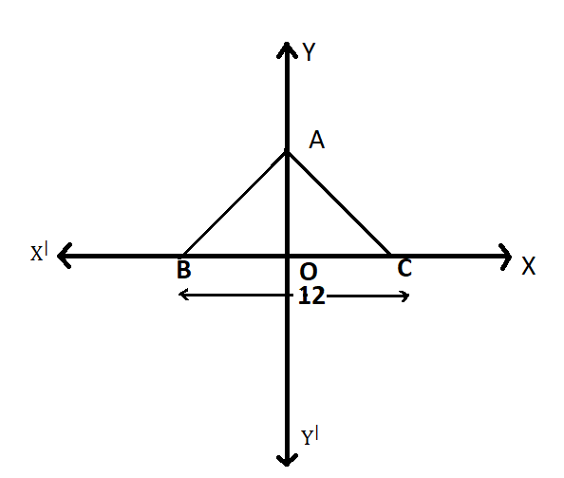

Fig. 1

1. Draw the line passing through (5, 7) & (7, 5). Find the coordinate of the points at which this line meets the X – axis & Y – axis.
2. Locate the coordinates of labelled points A, B, C, D, E, f, G & H in the following diagram.
3. Plot the following points on graph paper:

|  |  |  |  |  |  |
| --- | --- | --- | --- | --- | --- |
| x | 1 | 2 | 3 | 4 | 5 |
| y | 5 | 8 | 11 | 14 | 17 |

1. Draw a line passing through (5, 4) and (4, 5). Find the coordinates of the points at which this line meets the Y – axis.
2. Without plotting the points indicate the quadrant in which they will lie, if
3. Ordinate is -5 and abscissa is -3
4. Abscissa is 8 and ordinate is -2
5. Plot the following points and check whether they collinear or not.

(1, 3), (-2, -3), (-1, -1)

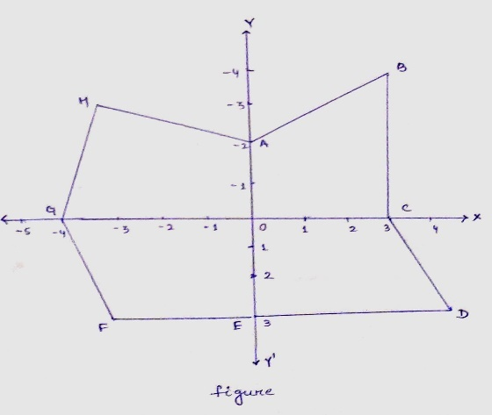

1. Write the coordinate of polygon ABCDEFG as shown

in the following figure:

1. Write the coordinates of a point on X – axis at a distance of 6 units from the origin in the positive direction of X – axis and then justify your answer.

**SHORT ANSWER TYPE-1I QUESTIONS (3 MARKS)**

1. Plot the points (x,y) given by the following table use scale 1cm = 0.25 units

|  |  |  |  |  |
| --- | --- | --- | --- | --- |
| X | 1.25 | 0.25 | 1.5 | -1.75 |
| Y | -0.5 | 1 | 1.5 | -0.25 |

1. Taking 0.5cm as 1 unit,plot the following points on graph paper A(1,3),B(-3,-1), C(1,-4) , D (-2,3),E (0,8), F (1,0).
2. From the figure answer the following fig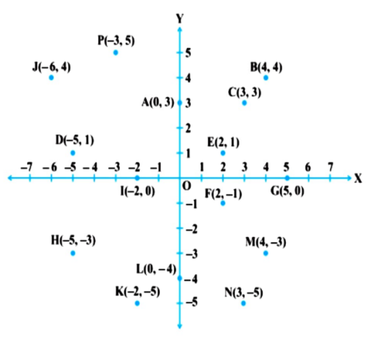

(i)Write the points whose abscissa is 0.

(ii) Write the points whose ordinate is 0

(iii) Write the points whose abscissa is -5.

1. Three vertices of a Square ABCD are A(5,3) ,B(-2,3) and D(5,-4) plot these points and find the co-ordinate of the vertex C.
2. Take a triangle ABC with A (3,0) B (-2,1) C (2,1) .find its mirror image .
3. Plot the points A(1,-1) B(4,5)
4. Draw a line segment joining these points . Write the coordinate of a point on this line segment between the points A and B
5. Extend this line segment and write the coordinates of a point on this line which lies outside the line segment AB.
6. Mention the quadrant or on which axis do each of the points (-2,4) (3,-1) (-1,0) (1,2) and (-3,-5) lies.verify your answer by locating them on Cartesian plane .
7. Plot the points A(4,4) B(-4,4) and join OA,OB and BA what figure do you obtain?
8. Take a quadrilateral ABCD A(-5,4) B(-5,2) C (-5,2)C(-3,3) and D (-3,4) find its mirror image w.r.t y-axis.
9. How will you describe the position of a table lamp on your study table to another person.

**LONG ANSWER TYPE QUESTIONS (5 MARKS)**

1. Points A(5, 3), B (-2, 3) & D(5, -4) are three vertices of a square ABCD. Plot these points on a graph paper & hence find the coordinates of the vertex C.
2. Write the coordinates of the vertices of a rectangle whose length & breath are 6 & 4 units respectively. One vertex at the origin & the longer side lies on the X – axis and one of the vertices lies in the third quadrant.
3. Plot the points P(0, -3), Q(0, 3) & R(6, 3). Find the coordinates of the point S such that PQRS is a square.
4. Plot the points A(2, -2) & B(5, 6).
5. Draw a line segment joining these points. Write the coordinates of a point on this line segment between the points A & B.
6. Extend this line segment & write the coordinates of a point on this line which lies outsides the line segment AB.
7. 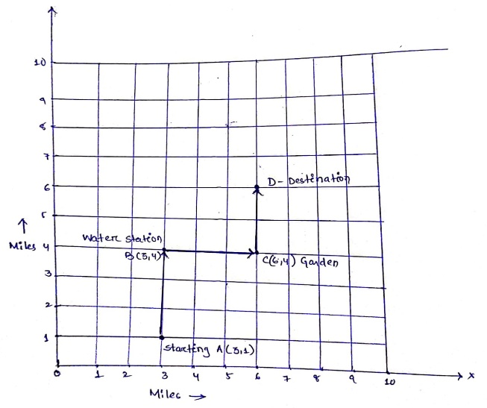Plot the points P(0, -3), Q(0, 3) & R(10, 3). Find the coordinates of the point S such that PQRS is a rectangle.
8. Take a triangle ABC with A(3, 0), B(-2, 1)

and C(2, 1). Find the mirror image.

1. From the below graph answer the following
2. Write the points whose abscissa is 0.
3. Write the points whose ordinate is 0.
4. Write the points whose abscissa is -5.
5. Write the points lies on IV quadrant.
6. The point A is how far from origin.

**CASE BASED TYPE QUESTIONS (4 MARKS)**

1. Fourfriends Shyam, Sudhir, Sagar, Sangram are standing in reference to a well situated at the origin with the following respective coordinates (2, 4), (-2, 4), (-2, -4) and (2, -4).

By putting these points on a single graph paper, the figure obtained is rectangle.

Based on the above information answer the following questions:

1. Sangram stands in which quadrant.
2. Find the distance between Shyam and Sudhir.
3. Find the perimeter of the rectangle formed.
4. Suhani was putting up one of her Painting in her living room. Before this Suhani had put a grid on the wall where each unit measured equals to a foot. The upper – left corner of the frame is at point C(1, 8) and the upper – right corner at D(7, 8). The bottom – left corner is at A(1, 2) and the bottom – right corner at B(7, 2).

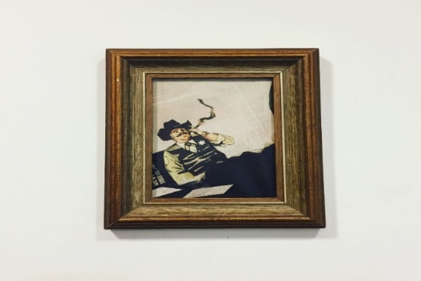

Based upon the above information answer the following questions:

1. Which sides of the Painting are parallel to X – axis?
2. Point A, B, C & D lie in which quadrant?
3. Find is the width of the Painting plus frame.

3 .Radha is participating in 8 miles walk. The organizers used a square coordinate grid to plot the course. The starting point is at A(3, 1). At B(3, 4), there’s a water station to make sure the walkers stay hydrated.

From water station, the walkway turns right and at C(6, 4) a garden is

situated to keep walkers fresh. From the garden, the walkway turns left and finally, Radha reaches at destination D to complete 8 miles.

Based upon above information answer the following questions:

1. Write the abscissa of destination point D.
2. Write the coordinate of destination point D.
3. How far is the water station from the starting point A?

**CHAPTER: INTRODUCTION TOEUCLID'S GEOMETRY**

**MULTIPLE CHOICE QUESTIONS (1 MARKS)**

1. A point has:

1. 0-dimension b. 1-dimension c. 2 dimensions d. 3 dimensions

2. Euclid's axiom that illustrates the statement that p + q = 10, then p + q + r = 10 + r is :

1. first b. second c. third d. fourth

3. From the following, the one having three dimensions:

1. point b. line c. solid d. plane

4. Point C is said to be lying between B and A if

1. AB + AC = BC b).AC = CB

c) BC + AB = AC d) A, C and B are collinear

5. From the following statements which statement is false?

1. Ray AB = Ray BA
2. A unique line can pass through two given points
3. A ray has one endpoint
4. Whole is greater than part

6. All right angles are equal to one another is a:

1. statement b. postulate c. theorem d. axiom

7. The boundaries of surfaces are

1. curves b. lines c. polygons d. none of these

8. Choose the correct one from the following

1. Two adjacent walls of a room are parallel planes
2. The ceiling and a wall of a room are parallel planes
3. The floor and ceiling of a room are parallel planes
4. The floor and a wall of a room are parallel planes

9. The triangles of the " Sri Yantra " are

1. equilateral triangles
2. isosceles triangles
3. scalene triangles
4. right angle triangles

10. The universal truth in all branches of mathematics are called as

1. axioms
2. theorems
3. postulates
4. corollaries

11. The famous treatise of Euclid's " The Elements " has

1. 10 chapters b. 12 chapters c. 13 chapters d. 14 chapters

12. There are ….. number of interwoven isosceles triangles in the" Sri Yantra " is

1. 8 b.9 c.10 d.14

13. Things which are double of the same thing are

1. equal b. halves of the same thing

c)unequal d.double of the same thing

14. Solids are the dimensions of :…

1. 2 b.3 c.1 d.0

15. In ancient India, altars combination of shape like rectangle, triangle and trapezium were used for

1. household rituals b.public worship c.both a and b d.none of them

16. A straight line falling on two straight lines makes the interior angles on the same side of it sum up to 140 degrees. Then if the two straight lines produced indefinitely, meet on the side on which the sum is :

1. less than 140 degrees
2. equal to 180 degrees
3. equal to 140 degrees
4. greater than 180 degrees

17. The dimensions of the earthen bricks used in the Indus Valley Civilization are the ratio of

1. 4 : 2 : 2 b.4:3:2 c.4:3:1 d.4:2:1

18. From the following that needs a proof is

1. axiom b. postulate c. theorem d. definition

19. Madhav is the same age as Mohan and the ages of Shivam and Mohan are equal. Find the axiom relates the ages of Madhav and Shivam.

1. third b. second c. first d. forth

20. Choose the false postulate of one of the following.

1. All right angles are equal
2. A circle can be drawn with any point as centre and any radius
3. A straight line may be drawn from any point to any other point.
4. A terminated line cannot be produced indefinitely.

**ASSERTION AND REASON QUESTIONS**

1. A : Two lines x and y do not have a common point.

R : Lines with constant perpendicular distance everywhere are parallel lines.

2. A : Angles of a square and a rectangle are equal.

R: All right angles are equal.

3. A : If AB = PQ and XY = PQ, then AP = XY.

R : Things equal to same thing are equal to each other.

4. A : A straight line may be drawn from any point to any other point in a plane.

R : At a given point infinitely many lines can be passed.

5. A : If AP = BQ where A, P, Q and B are the collinear points on a line, then AQ - PQ = BP - PQ.

R : When equals are subtracted from equals, then the remainders are equal.

6. A : Two lines l and m pass through two distinct points.

R : Through a given point infinitely many lines can pass.

1. A : A theorem needs a proof.

R : Theorems can be proved using axioms, postulates and theorems.

8. A : Point, line and plane are the undefined terms in the geometry.

R : Euclidean geometry is valid only for curved surface.

9. A : Everything is equal to itself.

R : Things coincident with one another are equal to one another.

10. A : If A, B and C are the three points on a line and B lies between A and C.

R: AB + BC = AC

**SHORT ANSWER TYPE - I (2mark) QUESTIONS**

1. p + 15 = 22, solve the equation and state the Euclid's axiom used.

2. C is the midpoint of the line segment PQ. Write the relationship between PC, QC and PQ with the axiom.

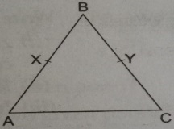3. The weights of two friends A and B are the same. If both of them take a lunch of 1.5 kg, then compare their weights using the EUCLID'S axiom.

4. Write EUCLID'S fifth postulate.

5. If P is the midpoint of line segment AB, prove that AP = ½ AB.

6. In the figure PQ = QR and PX = RY. Show that QX = QY.

7. Does Euclid's any postulate say about the existence of parallel lines. Explain.

8. The midpoint of line segment AB is C and D is the midpoint of AC. Prove that AD = ¼ AB.

9. An equilateral triangle is a polygon made of three-line segments out of which two sides are equal to the third one and each of its angles is 60 degrees. Define the terms used in this definition which you feel necessary. Justify.

10. If A, B and C are three points on a line and B lies between A and C, then show that AB + BC = AC with the axiom.

**SHORT ANSWER TYPE - II (3 mark)**

1. State the postulates of EUCLID'S.

2. B and C are the points lying on the line segment AD such that B is the midpoint of AC and C is the midpoint of BD. Draw the figure to represent this and prove that AB = ⅓ AD.

3. Read the following statement:

A square is a four-sided polygon in which three-line segments are equal to the fourth one and each of its angles is 90 degrees. Justify that all sides and angles of a square are equal.

1. 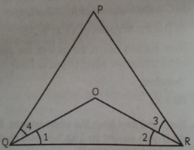A student draws the following figure on the black board

where < PQR = < PRQ and < OQP = < ORP. Show that < 1 = < 2.

**CASE STUDY BASED QUESTION**

1. South - East coastal states are cyclone prone states of India. In the last cyclone many people lost their lives and priorities. Two friends Madhav and Mohan decided to contribute equal amounts to the Prime Minister ' s Relief Fund which helps needy people suffering in the natural calamities.

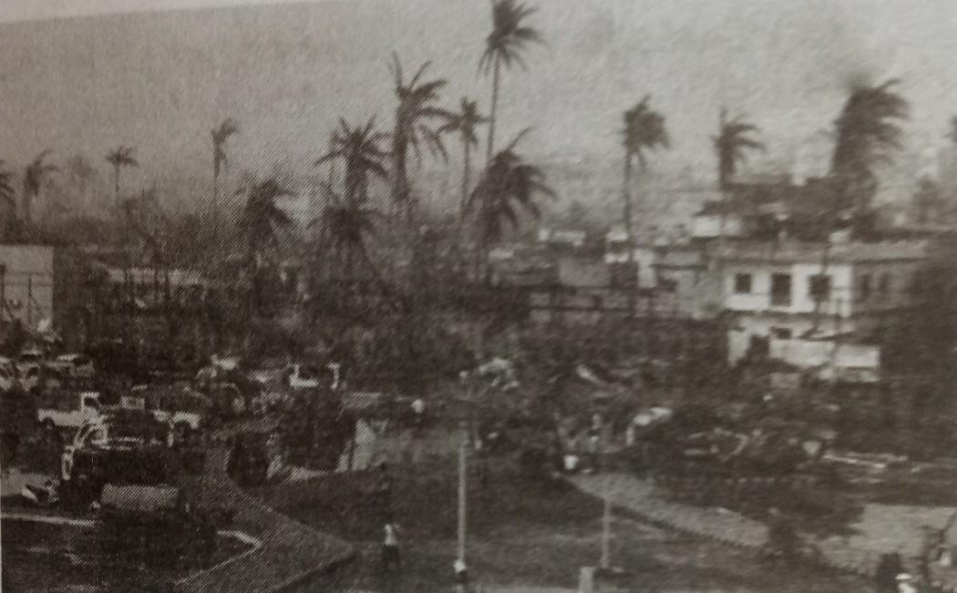

I). If Madhav contributed Rs. 5000, then find the amount Mohan contributed

II). Write the Euclid's axiom suits here.

III). If C is the midpoint of the line segment AB, then show that AC = ½ AB.

**CHAPTER- LINES AND ANGLES**

**MULTIPLE CHOICE QUESTIONS (1 MARKS)**

1. If one angle of a triangle is equal to the sum of the other two angles, then the triangle is……
2. An equilateral triangle. (b) an obtuse triangle (c) an isosceles triangle (d) a right triangle
3. In the given figure , if OP RS,
4. 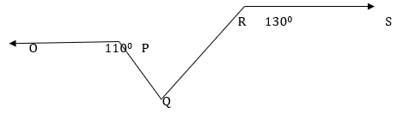400 (b) 500 (c) 600 (d) 700

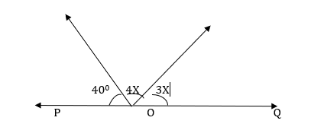

1. In the below figure , POQ is a line . The value of x is…….
2. 200 (b) 250 (c) 300  (d) 350
3. The measure of an angle is five times its complement angle. Find the angle.
4. 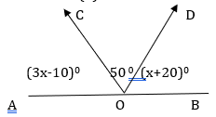250  (b) 350 (c) 650 (d) 750
5. In the given figure AOB is a straight line .

if

1. 400 (b) 600 (c) 800 (d) 500
2. An angle is one –fifth of its supplement angle. The measure of the angle is
3. 150 (b) 300 (c) 750 (d) 1500
4. An angle which measures more than 1800 but less than 3600 , is called…
5. An acute angle (b) an obtuse angle (c) straight angle (d) reflex angle

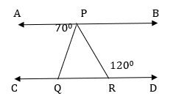

1. In the above figure
2. 500 (b) 600 (c) 400 (d) 350
3. 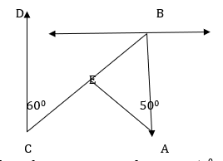

In the above figure ,

1. 500  (b) 600 (c) 700 (d) 550
2. Two complementary angles are such that twice the measure of the

one is equal to three times the measure of the other. The larger of the two measures

1. 720 (b) 540 (c) 630 (d) 360

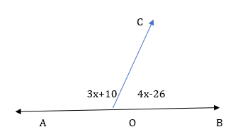 In the above given figure , AOB is a straight line,

If

1. 960 (b) 860
2. (c) 760 (d) 1060
3. Which of the following statements is false ?
4. Through a given point, only one straight line can be drawn.
5. Through two given points ,it is possible to draw one and only one straight line.
6. Two straight lines can intersect only at one point.
7. A segment can be produced to any desired length.
8. If two angles are complements of each other then each angle is ..
9. An acute angle. (b) an obtuse angle (c) a right angle (d) a reflex angle
10. 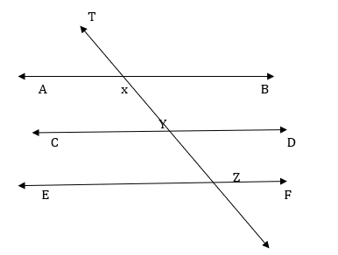

In the above figure AB

1. 1080 (b) 1260
2. (c) 1620 (d) 630

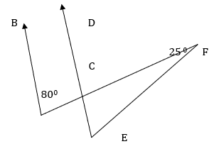

In the above figure ,

1. 650 (b) 550 (c) 450 (d) 750

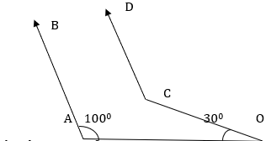

1. In the above given figure ,
2. 1300 (b) 1500 (c) 800  (d) 1000

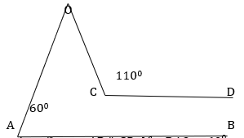

1. In the given figure ,
2. 700 (b) 600 (c) 500 (d) 400
3. 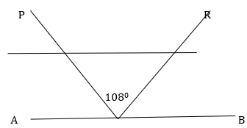

In the given figure , AB is a mirror, PQ is the incident ray and

QR is the reflected ray . If

1. 720 (b) 180 (c) 360 (d) 540
2. 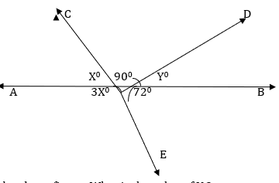

In the above figure, What is the value of Y ?

1. 360 (b) 540
2. (c) 630 (d) 720

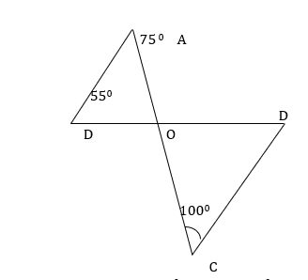

1. In the given figure ,
2. 200 (b) 250
3. (c) 300 (d) 350

**SECTION-B**

**ASSERTION AND REASON QUESTIONS**.

Q.NO-21 to Q.NO-30 Assertion and Reason questions. Choose the correct answers.

1. Both Assertion(A) and Reason(R) are correct and Reason(R) is the correct

Explanation for Assertion(A)

1. Both Assertion (A) Reason are correct and Reason (R) is not the correct explanation for Assertion(A)
2. Assertion(A) is true but Reason (R) is false.
3. Assertion(A) is false but Reason(R) is true.
4. Assertion(A) –Two angles are called adjacent if they have common vertex.

Reason (R) - The adjacent angle have common interior point.

1. Assertion –The sum of two adjacent angle is 1000 and one of them is 350 , then other is 650

Reason -Adjacent angles are always supplementary.

1. Assertion -700 is an acute type angle.

Reason - The angle which is less than 900 is known as acute angle.

1. Assertion –Sum of the pair of angles 1200 and 600 is supplementary.

Reason - Two angles the sum of whose measures is 1800 , are called supplementary angles.

1. Assertion- If two interior angles on the same side of the transversal intersecting two parallel

Lines are in the ratio 5:4 , then the greater of the two angles is 1000 .

Reason - If a transversal intersects two parallel lines, then the sum of interior angles on the same side of the transversal is 1800 .

1. Assertion –An angle is 140 more than its complementary angle, then the angle is 520 .

Reason - Two angles are said to be supplementary if their sum of measure of angles is 1800 .

1. Assertion- Supplement of angle is one fourth of itself. The measure of the angle is 1440 .

Reason - Two angles are said to be supplementary if their sum of measure of angles is 1800 .

1. Assertion – A line segment is a part of a line with two end points.

Reason - A line can be extended from both side.

1. Assertion – Two lines are said to be parallel when they do not meet at any point or which do

Not intersects each other.

Reason - Parallel lines never meet no matter how much they are extended in either direction.

1. Assertion – Two angles which are formed , opposite to each other , when two lines intersect at a

Point or vertex, are called vertically opposite angles.

Reason - A pair of vertically opposite angles are always equal to each other.

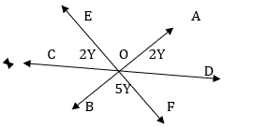**SHORT ANSWER TYPE-1 ( 2 MARKS EACH**)

1. In the above figure AB, CD, CD and EF are

three lines concurrent at O . Find the value of y .

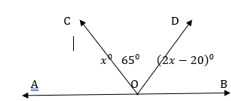

1. In the above figure, AOB is a straight line.

Find $∠AOC and ∠BOD$

1. 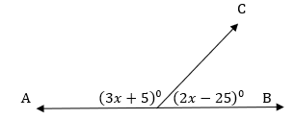In the above figure, what value of x will

make AOB a straight line?

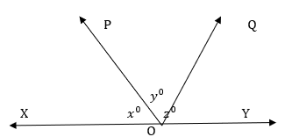

1. In the above figure, x:y:z = 5:4:6 .

If XOY is a straight line , find the value of

x, y and z

1. Two adjacent angles on a straight line are in the ratio 5:4 . Find the measure of each one of these angles.
2. If the difference between two complementary angles is 100 , then find angles.

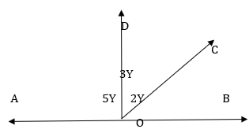

1. In the given figure. If AOB is a

then find the

measure of $∠BOC, ∠COD and ∠DOA$

1. Two adjacent angles are equal. Is it necessary that each of these angles will be a right angle? Justify your answer.
2. If one of the angles formed by two interesting lines is a right angle, what can you say about the other three angles? Give reason for your answer.
3. Two lines l and m are perpendicular to the same line n. Are l and m perpendicular to each other. Give reason for your answer.

**SHORT ANSWER TYPE-II (3 MARKS EACH)**

1. Prove that lines which are parallel to the same line are parallel to each other.
2. If two lines intersect each other, then show that the vertically opposite angles are equal.
3. 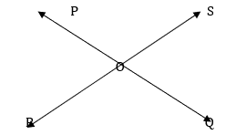In the above figure, lines PQ and RS intersects each other

at point O. If $∠POR:∠ROQ=5:7$, Find all the angles.

1. 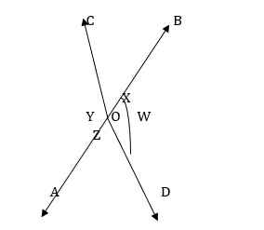Find the measure of an angle , if six times its complement is 120 less than twice its supplement.

45In the given figure, if x+ y =w + z , then prove that AOB is

a line.

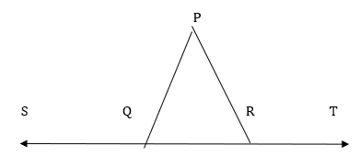

46. In the above figure, $∠PQR=∠PRQ ,$

$$prove that ∠PQS=∠PRT$$

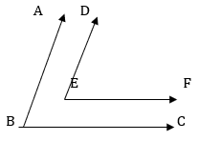47

In the given figure, BA $∥ED , and BC∥EF.$

$$Show that ∠ABC= ∠DEF$$

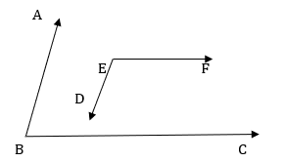

48.In the above figure, $BA∥ED and BC∥EF .$

$$Show that ∠ABC+ ∠DEF={180}^{0}$$

49.The measure of an angle is 8 times its complement. Find the angles.

50.If the measure of an angle is thrice the measure of its supplementary angle, then find the measure of angle.

**LONG ANSWER TYPE QUESTIONS (5 MARKS EACH)**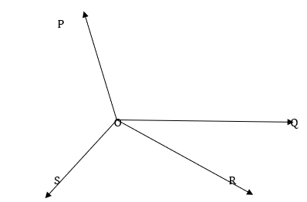

51.In the above figure, OP, OQ, OR and OS are four rays.

Prove that $∠POQ+∠ROQ+∠SOR+∠POS={360}^{0}$

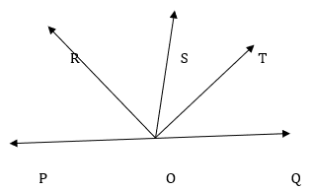51.In the above figure, ray OS stands on a line POQ. Ray OR

and ray OT are angle bisectors of $∠POS and ∠SOQ$

respectively. If $∠POS=x, find ∠ROT.$

52.Two lines are respectively perpendicular to two

parallel lines. Show that they are parallel to each other.

53. Prove that two lines that are respectively perpendicular to two intersecting lines intersect each other.

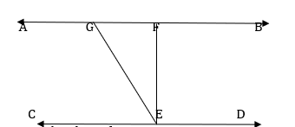54.Prove that through a given point, we can draw only one perpendicular to a given line.

55.In the above figure

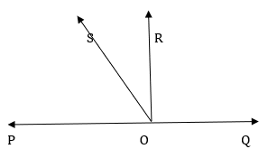

56. In the above figure, POQ is a line . Ray OR is

perpendicular to line PQ. OS is another ray lying between

rays OP and OR . Prove that $∠ROS=\frac{1}{2}\left(∠QOS-∠POS\right)$

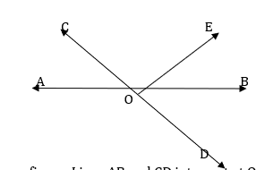57. In the above figure, Lines AB and CD intersect at O.

If $∠AOC+∠BOE={70}^{0} and ∠BOD={40}^{0} , find ∠BOE$

$$and reflex ∠COE$$

58.It is given that $∠XYZ={64}^{0}$ and XY is produced to point P.

Draw a figure from the given information. If ray YQ bisects

$$∠ZYP , Find ∠XYQ and reflex ∠QYP$$

**CASE STUDY BASED QUESTIONS.**

59. In a school the Mathematics teacher draw a geometrical figure on the ground, which is

Given in the above figure. Here line l is parallel to m and q is a transversal line. While drawing this figure , the teacher have no scale for measuring this length, but they know the side which is opposite to the smallest angle ,is smaller and the side which is opposite to the largest angle, is larger. In this game the teacher invite two students and said one to stand on point A and other to stand on point B . Then the teacher asked the following questions based on above data.

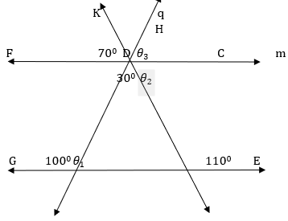

1. Find the measure of $∠ABD$
2. Find the measure of $∠θ_{1}+∠θ_{2}$
3. 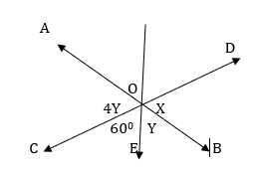Find the measure of $∠KDH .$

60.

Here $∠AOD=2Z$

From the above figure Answer the f///ollowing questions.

1. What is the value of x ?
2. 480 (b) 960 (c) 1000 (d) 1200
3. What is the value of y ?
4. 840 (b) 420 (c) 1000 (d) 240
5. Find the value of Z
6. 480 (b) 1000 (c) 420 (d)1200
7. What should be the value of x + 2z ?
8. 1480 (b) 3600 (c) 1800 (d) 1200
9. What is the relation between y and z ?
10. 2y+z=900 (b) 2y+z=1800 (c) 4y+2z=1200 (d) y=2z

61. BSE stands for a disease called Bovine spongiform Encephalopathy’ Bovine means that the disease affects cows , spongiform refers to the way the brain from a sick cow looks spongy under a microscope and encephalopathy indicates that it is a disease of the brain.

A farmer has a field ABCD formed by two pair of parallel roads as shown below in which

l $∥$ m and p $∥$ q. His four cows suffering from BSE.Thus, he tied them at four corners of the field ABCD. Answer the following questions from the below figure.

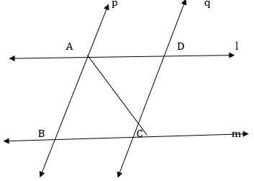

1. If a cow at C and cow at D is 2km apart, then what is the distance between cow at A and cow at B ?
2. If $∠B={45}^{0} , then find ∠D=?$
3. If we join BD such that BD meet AC at O and $∠BOC={30}^{0}, then$ what is the measure of $∠AOD ?$
4. 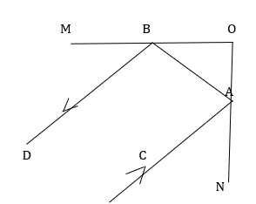In the above figure , MO and ON are two plane mirror

with a flat reflective Surface perpendicular to each

other. An incident ray of light CA strikes at ON at A.

The reflected ray corresponding to a given incident

ray ,is the ray that represents The light reflected by

the surface MO and BD is the reflected ray

1. If BO =3 cm, AB =5 cm then AO = ?
2. 3600 (b) 900 (c) 1800 (d) 2700
3. If the incident ray CA is---
4. Parallel to AB, and CAB=500, find ABD

**PRACTICE PAPER-1**

**Time allotted: 1 hour 30 minutes M.M:40**

**GENERAL INSTRUCTIONS:**

1. *This Question Paper has 5 Sections A-E.*

*2. Section A has 10 MCQs carrying 1 mark each.*

*3. Section B has 02 questions carrying 02 marks each.*

*4. Section C has 04 questions carrying 03 marks each.*

*5. Section D has 02 questions carrying 05 marks each.*

*6. Section E has 01 case based integrated units of assessment (04 marks) with subparts of the values of 1, 1 and 2 marks each respectively.*

*7. All Questions are compulsory. However, an internal choice in 01 Question of 5 marks, 01 Question of 3 marks and 01 Question of 2 marks has been provided. An internal choice has been provided in the 2marks question of Section E.*

*8. Draw neat figures wherever required. Take π =22/7 wherever required if not stated.*

**SECTION-A**

1. Which of the following is not a rational number?

(a) √16 (b) √(12/3) (c) √12 (d) √100

1. Degree of the zero polynomial is  
   (a) 0 (b) 1 (c) any real number (d) not defined
2. If *x* coordinate of a point is zero, then this point always lies

(a) in I quadrant (b) in II quadrant(c) on *x* – axis (d) on *y* – axis

1. Mirror image of the point (9, -8) in y-axis is  
   (a) ( -9,-8)(b) (9,8) (c) (-9,8) (d) (-8, 9)
2. If (x+2, 4)=(5, y - 2) then what are the values of x and y?

(a) 7,12 (b) 6,3 (c) 3,6 (d) 2,1

1. Total number of propositions in Euclid’s famous treatise “The Elements” is:

(a) 465 ( b) 460 (c) 13 (d) 55

1. 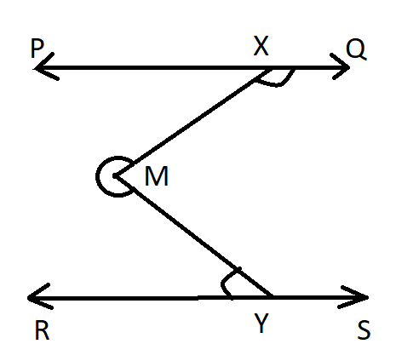The first known proof that “the circle is bisected by its diameter”

was given by  
(a) Pythagoras (b) Thales (c) Euclid (d) Hypatia

1. In the given figure if PQ || RS, reflex ∠XMY= 275°

and ∠ MXQ = 135°, then ∠ MYR =

(a) 85° (b) 75° (c) 40° (d) None of these

1. **If two interior angles on the same side of a transversal intersecting two parallel lines are in the ratio 2 : 3, then the greater of the two angles is:**

(a) 54° (b) 108° (c) 120° (d) 136°

1. ***Statement A (Assertion)*: $\sqrt{7}$ is an irrational number.**

***Statement R (Reason)*: Square root of a rational number is always irrational.**

1. Both assertion (A) and reason (R) are true and reason (R) is the correct explanation of assertion (A) .
2. Both assertion (A) and reason (R) are true and reason (R) is not the correct

explanation of assertion (A).

(c) Assertion (A) is true but reason (R) is false.

(d) Assertion (A) is false but reason (R) is true.

**SECTION-B**

1. If x + y = 12 and xy = 27, find the value of x3 + y3 .
2. Ram and Shyam have same weight. After 6 month both of them gained 2.5kg weight. Compare their weights by using suitable Euclid’s axiom.

**Or**

In the given figure triangle ABC is isosceles with AB=CB . X and Y are the mid points of AB and BC respectively. Show that AX = CY by using suitable Euclid’s axiom.

**SECTION-C**

1. 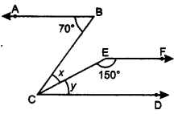Express 0.237373737……. in the form of $\frac{p}{q}$, where p and q are integers and $q≠0$.

**Or**

Find the value of a and b $in \frac{7+ \sqrt{5}}{7-\sqrt{5}}$– $\frac{7-\sqrt{5}}{7+\sqrt{5}}$ = a + $\frac{7}{11}\sqrt{5 }b$

1. Factorise: x3 + 13x2 + 32x + 20 (using factor theorem)
2. If AB || EF and EF || CD, then find the value of x and y.

**Or**

Prove that internal and external bisectors of an angle make a right angle with each other.

1. 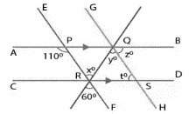If the coordinates of a point M are ( -2, 9) which can also be expressed as (1+x, y) and y > 0, then find in which quadrant do the following points lie:

P(y, x), Q(2,x), R(x, y-1), S(2x, -3y)

**SECTION-D**

1. Simplify: $\frac{3\sqrt{2}}{\sqrt{6}-\sqrt{3}}-\frac{4\sqrt{3}}{\sqrt{6}-\sqrt{2}}+\frac{2\sqrt{3}}{\sqrt{6}+\sqrt{2}}$

**Or**

If x = $\frac{\sqrt{2}+1}{\sqrt{2}-1}$ and y = $\frac{\sqrt{2}-1}{\sqrt{2}+1}$,find the value of x2 + y2 +xy .

1. In the figure, $AB∥CD and EF∥GH$,find thae values

of $x,y.z and t$

**SECTION-E**

1. When a tennis player hits a ball the ball moves up to a certain height , then it comes down. The path of tennis ball is shown in figure-1 and figure-2.This path is parabolic in shape.If the time taken in x-axis and height of the ball is taken in y-axis, we get a parabolic graph. A parabola is the graph that results from $p(x)=ax^{2}+bx+c$*.* In this case , $p(t) = 3 + 14t - 5t^{2}$ (where, ‘ $p(t)$’ is the height of the ball in feet and ‘t’is the time in second ).

*Based on the above case study answer the following questions:*

1. **Find the Coefficient of t2 in the given polynomial?**
2. **Find** the height of the ball 5 seconds after it is launched.
3. If height ‘h’ is given by $h=5t^{2} - 5t – 2$, After how many seconds of hitting the ball, the ball will teach a height of 8 feet?

**Or**

**Find all the possible zeroes of the given polynomial $p(t)$.**

**PRACTICE PAPER-2**

**Time allotted: 1 hour 30 minutes M.M:40**

**GENERAL INSTRUCTIONS:**

1. *This Question Paper has 5 Sections A-E.*

*2. Section A has 10 MCQs carrying 1 mark each.*

*3. Section B has 02 questions carrying 02 marks each.*

*4. Section C has 04 questions carrying 03 marks each.*

*5. Section D has 02 questions carrying 05 marks each.*

*6. Section E has 01 case based integrated units of assessment (04 marks) with subparts of the values of 1, 1 and 2 marks each respectively.*

*7. All Questions are compulsory. However, an internal choice in 01 Question of 5 marks, 01 Question of 3 marks and 01 Question of 2 marks has been provided. An internal choice has been provided in the 2marks question of Section E.*

*8. Draw neat figures wherever required. Take π =22/7 wherever required if not stated.*

**SECTION-A**

1**. The value of p(t) = 2+t+2t2−t3 when t=0 is**a) 2 b) 1 c) 4 d) 0

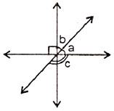2. If the perpendicular distance of a point P from the x-axis is 7 units and the foot of the perpendicular lies on the negative direction of x-axis, then the point P has:  
a) y-coordinate = 7 or –7 only b) y-coordinate = 7 only  
c) y-coordinate = –7 only d) x-coordinate = –7

3.In the given figure, if the angles a and b are in the ratio 2 : 3, then angle c is:  
a) 90ob)126oc) 144od) Obtuse angle

4.The product of any two irrational numbers is

a) always an irrational numberb) always a rationalnumber

c) always an integer d) sometimes rational, sometimes irrational

5.Boundaries of surfaces are:  
a) surfaces b) curves c) lines d) points

6.It is known that, if x + y = 10, then x + y + z = 10 + z. The Euclid’s axiom that illustrates this statement is:  
a) First Axiomb) Second Axiomc) Third Axiomd) Fourth Axiom

7.A reflex angle is:  
a) More than 90 degrees b) Equal to 90 degreesc) More than 180 degrees d) Equal to 180 degrees

8..  Abscissa of a point is positive in:  
a) I and II quadrantsb) I and IV quadrantsc) I quadrant onlyd) II quadrant only

9.On plotting P (–3, 8), Q (7, –5), R (–3, –8) and T (–7, 9) are plotted on the graph paper, then point(s) in the third quadrant are:  
a) P and Tb) Q and Rc) Only Rd) P and R

**DIRECTION:** In the question number 10 a statement of Assertion (A) is followed by a statement of Reason(R).

Choose the correct option.

10. Assertion (A): If (x + 1) is a factor of f(x) = x2 + ax + 2 then a = – 3 .

Reason (R) :If (x – a ) is a factor of p(x), if p(a) = 0.

a) Both Assertion (A) and Reason (R) are true and Reason ( R) is the correct

explanation for Assertion (A).

b) Both Assertion (A) and Reason ( R) are true and Reason (R) is not the correct

explanation for Assertion (A).

c) Assertion (A) is true and Reason (R) is false.

d) Assertion (A) is false and Reason (R) is true.

**SECTION-**B 22

11. Express 0.4323232… in the form *p/q*, where p and q are integers and q ≠ 0.

12. Plot the following points and check whether they are collinear or not:  
A(1, 3), B(-1, -1) & C (-2, -3).

**(SECTION-C) 4 $×$ 3**

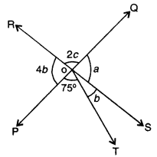13.In the given figure, two straight lines PQ and RS intersect each other at O.

If ∠POT = 75°, find the values of a, b,c.

14. Find the coordinates of the point  
(i) which lies on x and y-axes both.  
(ii) whose ordinate is – 4 and which lies on y-axis.  
(iii) whose abscissa is 5 and which lies on x-axis.

15.If $x^{p}$ = $y^{q}$ = $({xy)}^{pq}$, show that p+q =1.

OR

If $x^{a}$ = $c^{b}$ and $x^{c}$ = $c^{a}$, then prove that $a^{2}$ = bc.

16.Factorize:- (i) $\frac{l^{3}}{m^{3}}$ + $\frac{m^{3}}{n^{3}}$ + $\frac{n^{3}}{l^{3}}$-3

**(SECTION-D) 1 $×$ 4**

**17.CASE STUDY**

Mr Roy , a Mathematics teacher explained some key points of unit I of class IX to his students. Some are given here.There are infinite rational numbers between any two rational numbers.Rationalizations of a denominator mean to change the irrational denominator to rational form.A number is irrational if its decimal form is non- terminating/non-recurring.

On the basis of these key-points, answer the following questions.

a)Find the reciprocal of $√$ 2+3 ?

b) Find a rational number between $√$ 2 and $√$ 3 .

c) Find the value of ($√$ 11+ $√$ 7 ) ($√$ 11- $√$ 7 ) ?

OR

Evaluate: $\sqrt{5-2√6}$.

**(SECTION-E)**25

18. If a + b + c = 6 and ab + bc + ca = 11, find the value of a3+b3+c3− 3abc.

OR

Factorize:-

i) + + 1

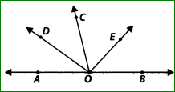ii)-

19. In the given figure, OD is the bisector of ∠AOC,

OE is the bisector of ∠BOC and OD ⊥ OE. Show that the

points A, O and B are collinear.