D.A.V. International School, Amritsar.
CLASS – III Holiday Home Work (2015-16) (Assignment Sheets)

---------------------------------------------------------------------------------------------------------------------------------------

ENGLISH
- Take one scrap book, cut and paste two newspaper articles and circle the nouns used in it. Refer to the sports/ Education / Business section of the newspaper. (III-A, III- B, III-C, III-D, III-E)

- Find out 20 unfamiliar words from the book that you read. Write the meanings and also write their antonyms (opposites). (III-F, III-G, III-H, III- I)

WORDS | MEANINGS | ANTONYMS(OPPOSITES)

- Read any story of your choice and complete the story map ( Compulsory for all)

COMPUTER SCIENCE

- Make a pocket dictionary of computer related terms (A-Z) at least three words of each. (III – A, B, C & D)

- Collect any 10 latest news on computer and Paste on A4 Sheet. (III – E, F, G ,H & I)

SCIENCE (PROJECTS)

- Make a table mat of sun / moon / earth (any one) and laminate it. (Compulary for all)

- Make a file cover
Topic: - Health is Wealth / Water (III-A, III-B, III-C, III-D, III- E)

Make a hanging bird feeder with waste material in a decorative manner.
(III-F, III-G, III-H, III-I)

MATHS

CH-1. Numbers up to 9999.
Page 8 Worksheet 3 sum 1, 2, 3 (full)
Page 9 Worksheet 4 sum 1, 2 (full)
page 10 Worksheet 5 sum 1 (full)
page 13 Worksheet 7 sum 4, 5 (full)

CH- 2 Additions
Page 20 Worksheet 2 sum 2 (full)
Page 23 Worksheet 4 sum 2 (full)

CH - 3 Subtractions
Page 31 Worksheet 4 sum 1- 6
Page 34 Brain Teasers sum 2, 3
Page 35 Brain Teasers sum 4,5,6

CH- 4 Multiplications
Page 37 Worksheet 1 sum 1-9
Page 39 Worksheet 2 sum 1- 12

* Tables 2-15 (They will do on separate Maths Copy)

::2::
SOCIAL SCIENCE

- Variation in styles of Dressing in India

The dresses like sarees, dhotis, Kurtas, caps are worn in different style in different states and are known by different names like (Lungi – is called vesti in Tamil Nadu]. Paste the pictures of different styles of wearing a dress, its name and name of the state it belongs to. Do it on coloured A4 sheet and spiral bind it.
Sarees – Section 3 – A, B, I
Dhotis – Section 3 – C, D
Kurtas – Section 3 – E, F
Caps – Section 3 – G, H

- Design a poster that will encourage people to reuse, recycle and reserve water.
- Read all the chapters (1, 2, 3, 4 and map of northern and western states) done in month of April, May.

HINDI

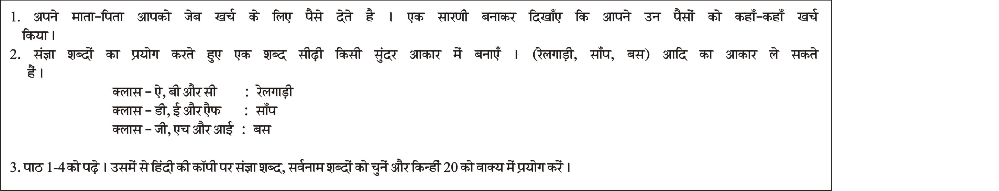

PUNJABI

